SCENARIO: | It is necessary to take the example at the end of the year 2022ACT Period 12.
AREA: | DATI_SALDI_LORDI, DATI_NOTE, DATI_COMMENTI, DATI_SALDI_LORDI_IC, DATI_SALDI_CONSO | STATUS: | OPEN / APPROVED
Responsible | Diego Felipe Rozo | EXECUTION  DATE (MM/DD/YYYY): |  | 08/18/2023

SYSTEM DATA
SYSTEM | ENVIRONMENT | DATE LAST VERSION (MM/DD/YYY) | VERSION
TUP – CCH Tagetik | ABC Inc. | 10/05/2022 | 5.3.21.303

Table of Contents
1. Tables of CCH Tagetik 3
1.1. DATI_SALDI_LORDI 3
1.2 DATI_SALDI_IC 4
1.3 DATI_SALDI_CONSO_1 5
1.4 DATI_RETT 6
1.5 DATI_RETT_RIGA 7
1.6 DATI_RETT_RIGA_CONS_1 10
1.7 DATI_RETT_RIGA_CONS_2 10
1.8 DATI_RETT_RIGA_CONS_3 11
1.9 DATI_CAMBIO 12
1.10 DATI_NOTE 12
2. How to add and view a note from DSL 14
2.1 Ways to view a note from DSL 16
3. DATI_NOTE and DATI_COMMENTI 18
3. How to add data to the DATI_NOTE 20
1.1.1.1 Entity journals (as well as the consolidation journals) logically consists of two parts: 20
4. Uploading Journal Data using an ETL: 21
4.1. Journal Data ETL Configuration 21
4.2. Journal Data Excel File Configuration 22
4.2.1. Entity Journal Upload File Sheets 22
4.2.2. Consolidation Journal Upload File Sheets 26
4.3. How to upload Journal Data using ETL 30
4.4. Common Errors 37
4.4.1. Error due to the value of the counterparty Entity: 37
4.4.2. Error due to the category that is different between the header and the row: 38
4.4.3. The account code doesn’t exist: 38
4.4.4. The Currency is different from the Header: 39

- Tables of CCH Tagetik
The field "NOTE" is displayed in the following tables highlighted in orange.
  - DATI_SALDI_LORDI
This table contains the original gross amount. This table contains the following columns with essential characteristics.
Column Name | Data Type | Mandatory | Comment | PK | Parent Table Name
OID_DATI_SALDI_LORDI | varchar(36) | Yes | OID_DATI_SALDI_LORDI | Yes
COD_SCENARIO | varchar(15) | Yes | Scenario code. This is an active original scenario. | Yes | SCENARIO_PERIODO
COD_PERIODO | varchar(2) | Yes | Period code. This is a period belonging to the Scenario | Yes | SCENARIO_PERIODO
COD_AZIENDA | varchar(30) | Yes | Entity code | No | AZIENDA
COD_CONTO | varchar(30) | Yes | Account code | No | CONTO
COD_DEST1 | varchar(30) | No | Custom Dimension 1: Custom Dimension element code | No | DEST1
COD_DEST2 | varchar(30) | No | Custom Dimension 2: Custom Dimension element code | No | DEST2
COD_DEST3 | varchar(30) | No | Custom Dimension 3: Custom Dimension element code | No | DEST3
COD_DEST4 | varchar(30) | No | Custom Dimension 4: Custom Dimension element code | No | DEST4
COD_DEST5 | varchar(30) | No | Custom Dimension 5: Custom Dimension element code | No | DEST5
COD_CATEGORIA | varchar(30) | Yes | Category code. This is an "Amount" category | No | CATEGORIA
IMPORTO | numeric(27) | Yes | Amount in entity currency | No
COD_VALUTA | varchar(5) | No | Entity currency code | No | VALUTA
IMPORTO_VALUTA_ORIGINARIA | numeric(27) | Yes | Amount in transaction currency | No
COD_VALUTA_ORIGINARIA | varchar(5) | No | Transaction currency code | No | VALUTA
NOTE | varchar(1000) | No | Notes | No

  - DATI_SALDI_IC
This table contains the intercompany entries. This table contains the following columns with essential characteristics.
Column Name | Data Type | Mandatory | Comment | PK | Parent Table Name
OID_DATI_SALDI_IC | varchar(36) | Yes | OID_DATI_SALDI_IC | Yes
COD_SCENARIO | varchar(15) | Yes | Scenario code. This is an active original scenario | No | SCENARIO_PERIODO
COD_PERIODO | varchar(2) | Yes | Period code. This is a period belonging to the Scenario | No | SCENARIO_PERIODO
COD_AZIENDA | varchar(30) | Yes | Declaring Entity code | No | AZIENDA
COD_CONTO | varchar(30) | Yes | Account code | No | CONTO
COD_DEST1 | varchar(30) | No | Custom Dimension 1: Custom Dimension element code | No | DEST1
COD_DEST2 | varchar(30) | No | Custom Dimension 2: Custom Dimension element code | No | DEST2
COD_DEST3 | varchar(30) | No | Custom Dimension 3: Custom Dimension element code | No | DEST3
COD_DEST4 | varchar(30) | No | Custom Dimension 4: Custom Dimension element code | No | DEST4
COD_DEST5 | varchar(30) | No | Custom Dimension 5: Custom Dimension element code | No | DEST5
COD_CATEGORIA | varchar(30) | Yes | Category code. This is an "Amount" category | No | CATEGORIA
COD_AZI_CTP | varchar(30) | No | Counterparty Entity code | No | AZIENDA
COD_DEST2_CTP | varchar(30) | No | Code of the Custom Dimension 2 element used as counterparty | No | DEST2
COD_VALUTA_DOC | varchar(5) | No | Transaction currency code | No | VALUTA
IMPORTO_VALUTA_DOC | numeric(27) | Yes | Amount in transaction currency | No
COD_VALUTA | varchar(5) | No | Entity currency code | No | VALUTA
IMPORTO | numeric(27) | Yes | Amount in entity currency | No
NOTE | varchar(1000) | No | Additional information | No

  - DATI_SALDI_CONSO_1
This table contains data related to the Consolidated amounts on the Proportional amount type. This table contains the following columns with essential characteristics.
Column Name | Data Type | Mandatory | Comment | PK | Parent Table Name
COD_SCENARIO | varchar(15) | Yes | Scenario code. This is an active consolidation scenario | No | SCENARIO
COD_PERIODO | varchar(2) | Yes | Period code. This is a period belonging to the Scenario | No | SCENARIO_PERIODO
COD_AZIENDA | varchar(30) | Yes | Entity code | No | AZIENDA
COD_CONTO | varchar(30) | Yes | Account code | No | CONTO
COD_DEST1 | varchar(30) | No | Custom Dimension 1: Custom Dimension element code | No | DEST1
COD_DEST2 | varchar(30) | No | Custom Dimension 2: Custom Dimension element code | No | DEST2
COD_DEST3 | varchar(30) | No | Custom Dimension 3: Custom Dimension element code | No | DEST3
COD_DEST4 | varchar(30) | No | Custom Dimension 4: Custom Dimension element code | No | DEST4
COD_DEST5 | varchar(30) | No | Custom Dimension 5: Custom Dimension element code | No | DEST5
COD_CATEGORIA | varchar(30) | Yes | Category code. This is an "Amount" category | No | CATEGORIA
COD_AZI_CTP | varchar(30) | No | Counterparty Entity code | No | AZIENDA
COD_DEST2_CTP | varchar(30) | No | Code of the Custom Dimension 2 element used as counterparty | No | DEST2
COD_VALUTA_DOC | varchar(5) | No | Transaction currency code | No | VALUTA
IMPORTO_VALUTA_DOC | numeric(27) | Yes | Amount in transaction currency | No
COD_VALUTA | varchar(5) | No | Entity currency code | No | VALUTA
IMPORTO | numeric(27) | Yes | Amount in entity currency | No
COD_VALUTA3 | varchar(5) | No | Entity currency | No | VALUTA
NOTE | varchar(1000) | No | Additional information | No

The difference with the DATI_SALDI_CONSO_2 table is that this one brings the consolidated amounts in converted amount type, the DATI_SALDI_CONSO_3 brings the consolidated amounts in consolidable amount type.

  - DATI_RETT
This table contains the headers of the Preconsolidation and Consolidation adjustment. This table contains the following columns with essential characteristics.
Column Name | Data Type | Mandatory | Comment | PK | Parent Table Name
COD_SCENARIO | varchar(15) | Yes | Scenario code. This is an active original scenario. | Yes | SCENARIO_PERIODO
COD_PERIODO | varchar(2) | Yes | Period code. This is a period belonging to the Scenario | Yes | SCENARIO_PERIODO
NUM_RETTIFICA | varchar(200) | Yes | The adjustment number | Yes
COD_AZIENDA1 | varchar(30) | No | Entity code for the preconsolidation adjustmentCode of the first entity for the consolidation adjustment | No | AZIENDA
COD_DEST21 | varchar(30) | No | Code of the Custom Dimension 2 element used as counterparty for the Entity 1 adjustment | No | DEST2
COD_AZIENDA2 | varchar(30) | No | Code of the second entity. Only for consolidation adjustment | No | AZIENDA
COD_DEST22 | varchar(30) | No | Code of the Custom Dimension 2 element used as counterparty for the Entity 2 adjustment | No | DEST2
NOTE | varchar(1000) | No | Adjustment description | No
COD_CATEGORIA | varchar(30) | No | Category code. Specifies the adjustment type | No | CATEGORIA
COD_VALUTA | varchar(5) | No | Currency code | No | VALUTA
FLAG_DOCUMENTO | numeric(1) | No | FLAG_DOCUMENTO | No
FLAG_DOCUMENTO | numeric(1) | No | Specifies if the journal has attached documents. | No
FLAG_DOCUMENTO | numeric(1) | No | 0 = the journal does not have attached documents | No
FLAG_DOCUMENTO | numeric(1) | No | 1 = the journal has attached documents | No
FLAG_PERIODICO | numeric(1) | No | Specifies if the journal has to be managed in periodic mode | No
FLAG_DRAFT | numeric(1) | Yes | [TODO: null] | No
  - DATI_RETT_RIGA
This table contains all the adjustments rows, that can be both manual or automatically generated by the system. This table contains the following columns with essential characteristics.
Column Name | Data Type | Mandatory | Comment | PK | Parent Table Name
OID_DATI_RETT_RIGA | varchar(36) | Yes | OID_DATI_RETT_RIGA | Yes
COD_SCENARIO | varchar(15) | Yes | Scenario code. This is an active original scenario. | Yes | DATI_RETT
COD_PERIODO | varchar(2) | Yes | Period code. This is a period belonging to the Scenario. | Yes | DATI_RETT
NUM_RETTIFICA | varchar(200) | Yes | The adjustment number | Yes | DATI_RETT
COD_AZIENDA | varchar(30) | Yes | COD_AZIENDA | No | AZIENDA
COD_AZIENDA | varchar(30) | Yes | Entity code for the preconsolidation adjustment (must be the same as DATI_RETT.COD_AZIENDA1) | No | AZIENDA
COD_AZIENDA | varchar(30) | Yes | Declaring Entity Code for the consolidation adjustment | No | AZIENDA
COD_CONTO | varchar(30) | Yes | Account code | No | CONTO
COD_DEST1 | varchar(30) | No | Custom Dimension 1: Custom Dimension element code | No | DEST1
COD_DEST2 | varchar(30) | No | Custom Dimension 2: Custom Dimension element code | No | DEST2
COD_DEST3 | varchar(30) | No | Custom Dimension 3: Custom Dimension element code | No | DEST3
COD_DEST4 | varchar(30) | No | Custom Dimension 4: Custom Dimension element code | No | DEST4
COD_DEST5 | varchar(30) | No | Custom Dimension 5: Custom Dimension element code | No | DEST5
COD_CATEGORIA | varchar(30) | Yes | Category code. (must be the same as DATI_RETT.COD_CATEGORIA) | No | CATEGORIA
COD_AZI_CTP | varchar(30) | No | Code of Entity element used as counterparty for IC figures adjustment | No | AZIENDA
COD_DEST2_CTP | varchar(30) | No | Code of Custom Dimension 2 element used as counterparty for IC figures adjustment. | No | DEST2
COD_AZI_CTP_SEGMENT | varchar(30) | No | COD_AZI_CTP_SEGMENT | No | AZIENDA
COD_AZI_CTP_SEGMENT | varchar(30) | No | Segment Ctp Entity code. | No | AZIENDA
COD_AZI_CTP_SEGMENT | varchar(30) | No | If the "Many to many relationship" field on the journal header is "No", when saving: | No | AZIENDA
COD_AZI_CTP_SEGMENT | varchar(30) | No | if the declaring Entity corresponds to the Entity 1 of the header, the system sets this field with the Entity 2 of the header if the declaring Entity corresponds to the Entity 2 of the header, the system sets this field with the Entity 1 of the header | No | AZIENDA
COD_DEST2_CTP_SEGMENT | varchar(30) | No | COD_DEST2_CTP_SEGMENT | No | DEST2
COD_DEST2_CTP_SEGMENT | varchar(30) | No | Segment Ctp custom dimension 2 code. | No | DEST2
COD_DEST2_CTP_SEGMENT | varchar(30) | No | If the "Many to many relationship" field on the journal header is "No", when saving: | No | DEST2
COD_DEST2_CTP_SEGMENT | varchar(30) | No | if the declaring Entity corresponds to the Entity 1 of the header, the system sets this field with the CTP 2 Custom dimension 2 of the header if the declaring Entity corresponds to the Entity 2 of the header, the system sets this field with the CTP 1 Custom dimension 2 of the header | No | DEST2
COD_VALUTA | varchar(5) | No | COD_VALUTA | No | VALUTA
COD_VALUTA | varchar(5) | No | Entity journal: | No | VALUTA
COD_VALUTA | varchar(5) | No | Entity currency code | No | VALUTA
COD_VALUTA | varchar(5) | No | Consolidation journal: | No | VALUTA
COD_VALUTA | varchar(5) | No | Journal currency code | No | VALUTA
IMPORTO | numeric(27) | Yes | IMPORTO | No
IMPORTO | numeric(27) | Yes | Entity journal | No
IMPORTO | numeric(27) | Yes | Amount in entity currency | No
IMPORTO | numeric(27) | Yes | Consolidation journal | No
IMPORTO | numeric(27) | Yes | Amount in Journal currency | No
COD_VALUTA2 | varchar(5) | No | COD_VALUTA2 | No | VALUTA
COD_VALUTA2 | varchar(5) | No | Entity journal | No | VALUTA
COD_VALUTA2 | varchar(5) | No | Transaction currency code | No | VALUTA
COD_VALUTA2 | varchar(5) | No | Consolidation journal | No | VALUTA
COD_VALUTA2 | varchar(5) | No | Entity currency code | No | VALUTA
IMPORTO2 | numeric(27) | Yes | IMPORTO2 | No
IMPORTO2 | numeric(27) | Yes | Entity journal | No
IMPORTO2 | numeric(27) | Yes | Amount in transaction currency | No
IMPORTO2 | numeric(27) | Yes | Consolidation journal | No
IMPORTO2 | numeric(27) | Yes | Amount in entity currency | No
NOTE | varchar(1000) | No | Additional information on the adjustment row | No
FLAG_FORZA_CAMBIO | numeric(1) | No | FLAG_FORZA_CAMBIO | No
FLAG_FORZA_CAMBIO | numeric(1) | No | Specifies if the user wants to override the exchange rate for the conversion of the amount to the Entity's exchange rate on the adjustment's row. | No
FLAG_FORZA_CAMBIO | numeric(1) | No | 0 = The exchange rate is not overridden for the record | No
FLAG_FORZA_CAMBIO | numeric(1) | No | 1 = The exchange rate is overridden for the record | No
COD_VALUTA_TRANSAZIONE | varchar(5) | No | [TODO: cpm.datamodelxml.DATI_RETT_RIGA.COD_VALUTA_TRANSAZIONE] | No | VALUTA
IMPORTO_VALUTA_TRANSAZIONE | numeric(27) | No | IMPORTO_VALUTA_TRANSAZIONE | No
IMPORTO_VALUTA_TRANSAZIONE | numeric(27) | No | Entity journal | No
IMPORTO_VALUTA_TRANSAZIONE | numeric(27) | No | Null | No
IMPORTO_VALUTA_TRANSAZIONE | numeric(27) | No | Consolidation journal | No
IMPORTO_VALUTA_TRANSAZIONE | numeric(27) | No | Amount in transaction currency | No

  - DATI_RETT_RIGA_CONS_1
This table contains data related to the Consolidated adjustments on the Proportional amount type.

The DATI_RETT_RIGA_CONS1 contains the same columns as the DATI_RETT_RIGA table. Except for;

FLAG_FORZA_CAMBIO
OID_DATI_RETT_RIGA
- And continue a new column as shown below;
Column Name | Data Type | Mandatory | Comment | PK | Parent Table Name
COD_VALUTA3 | varchar(5) | No | COD_VALUTA3  Entity journal  Transaction currency code  Consolidation journal  Journal currency code | No | VALUTA

  - DATI_RETT_RIGA_CONS_2
This table contains data related to the Consolidated adjustments on the Converted amount type. The DATI_RETT_RIGA_CONS2 contains the same columns as the DATI_RETT_RIGA_CONS_1 table. Except for;

COD_VALUTA_TRANSAZIONE
IMPORTO_VALUTA_TRANSAZIONE

  - DATI_RETT_RIGA_CONS_3
This table contains data related to the Consolidated adjustments on the Consolidable amount type. The DATI_RETT_RIGA_CONS3 contains the same columns as the DATI_RETT_RIGA_CONS_2 table. Except for;

COD_VALUTA_TRANSAZIONE
IMPORTO_VALUTA_TRANSAZIONE
Column Name | Data Type | Manda  tory | Parent Table Name | DATI_RETT_  RIGA_CONS_1 | DATI_RETT_  RIGA_CONS_2 | DATI_RETT  _RIGA_CONS_3
COD_SCENARIO | varchar(15) | Yes | SCENARIO | X | X | X
COD_PERIODO | varchar(2) | Yes | SCENARIO_PERIODO | X | X | X
NUM_RETTIFICA | varchar(200) | Yes |  | X | X | X
COD_AZIENDA | varchar(30) | Yes | AZIENDA | X | X | X
COD_CONTO | varchar(30) | Yes | CONTO | X | X | X
COD_DEST1 | varchar(30) | No | DEST1 | X | X | X
COD_DEST2 | varchar(30) | No | DEST2 | X | X | X
COD_DEST3 | varchar(30) | No | DEST3 | X | X | X
COD_DEST4 | varchar(30) | No | DEST4 | X | X | X
COD_DEST5 | varchar(30) | No | DEST5 | X | X | X
COD_CATEGORIA | varchar(30) | Yes | CATEGORIA | X | X | X
COD_AZI_CTP | varchar(30) | No | AZIENDA | X | X | X
COD_DEST2_CTP | varchar(30) | No | DEST2 |  |  | X
COD_AZI_CTP_SEGMENT | varchar(30) | No | AZIENDA | X | X | X
COD_DEST2_CTP_SEGMENT | varchar(30) | No | DEST2 | X | X | X
COD_VALUTA | varchar(5) | No | VALUTA | X | X | X
IMPORTO | numeric(21) | Yes |  | X | X | X
COD_VALUTA2 | varchar(5) | No | VALUTA | X | X | X
IMPORTO2 | numeric(21) | Yes |  | X | X | X
COD_VALUTA3 | varchar(5) | No | VALUTA | X | X | X
NOTE | varchar(1000) | No |  | X | X | X
COD_VALUTA_TRANSAZIONE | varchar(5) | No | VALUTA | X | NA | NA
IMPORTO_VALUTA_  TRANSAZIONE | varchar(21) | No |  | X | NA | NA
  - DATI_CAMBIO
This table contains the exchange rate.
Column Name | Data Type | Mandatory | PK | Parent Table Name
COD_SCENARIO | varchar(15) | Yes | Yes | SCENARIO_PERIODO
COD_PERIODO | varchar(2) | Yes | Yes | SCENARIO_PERIODO
COD_VALUTA | varchar(5) | Yes | Yes | VALUTA
CAMBIO_MEDIO | numeric(21) | No | No
CAMBIO_PERIODO | numeric(21) | No | No
CAMBIO_FINALE | numeric(21) | No | No
  - DATI_NOTE
The notes, which the user can insert from reports, are stored in this table.
NOTES: These notes are not referred to particular amounts inserted into the previous table but to the dimensions assigned to the report’s cell.

Column Name | Data Type | Mandatory | PK | Parent Table Name
OID_DATI_NOTE | varchar(36) | Yes | Yes
COD_SCENARIO | varchar(15) | Yes | Yes | SCENARIO_PERIODO
COD_PERIODO | varchar(2) | Yes | Yes | SCENARIO_PERIODO
COD_AZIENDA | varchar(30) | Yes | No | AZIENDA
COD_CONTO | varchar(30) | Yes | No | CONTO
COD_DEST1 | varchar(30) | No | No | DEST1
COD_DEST2 | varchar(30) | No | No | DEST2
COD_DEST3 | varchar(30) | No | No | DEST3
COD_DEST4 | varchar(30) | No | No | DEST4
COD_DEST5 | varchar(30) | No | No | DEST5
COD_CATEGORIA | varchar(30) | Yes | No | CATEGORIA
COD_AZI_CTP | varchar(30) | No | No | AZIENDA
COD_DEST2_CTP | varchar(30) | No | No | DEST2
NOTE | varchar(max)(-1) | No | No

- How to add and view a note from DSL
The DSL table has a column called NOTE. This contains the calculation logic code that created the row as shown in the following image;
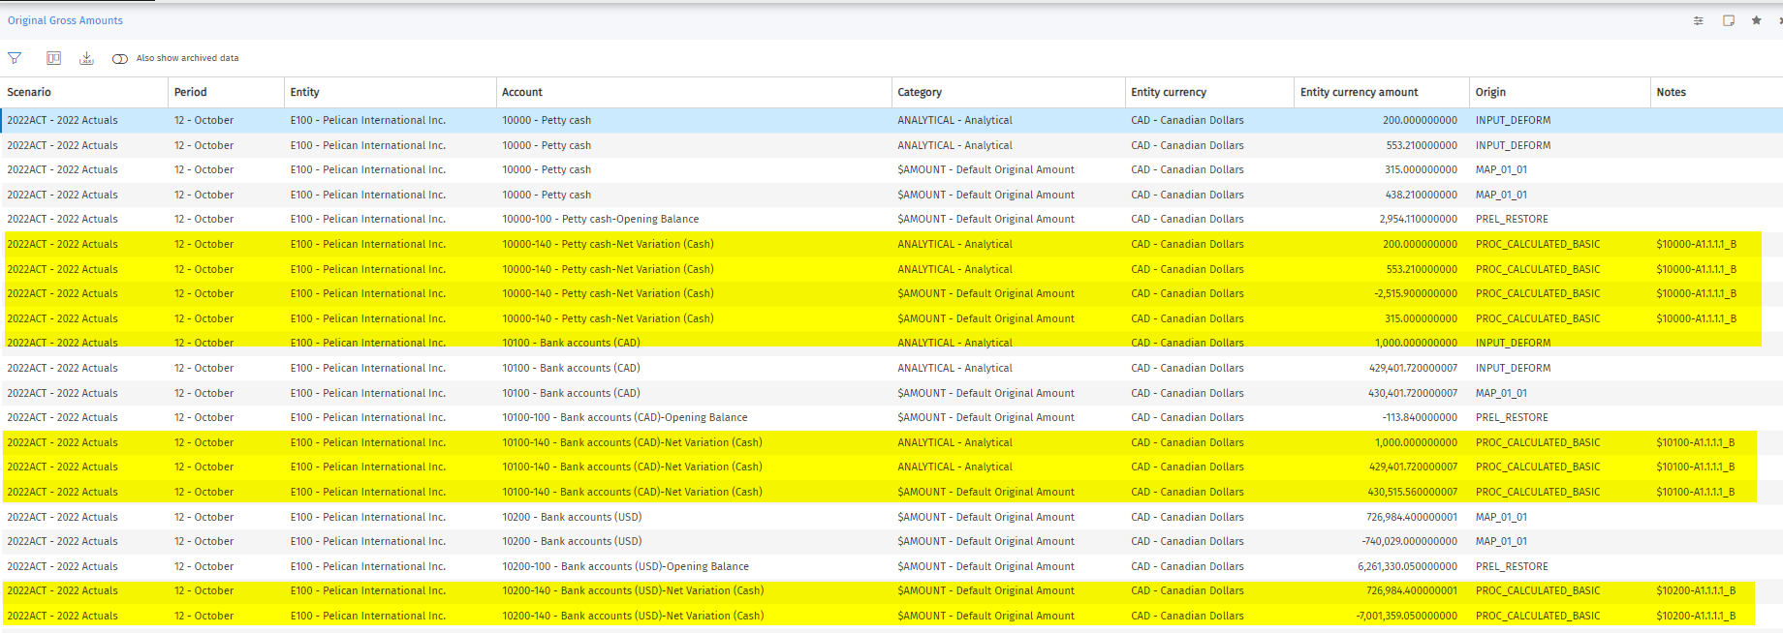
Screenshot 1 – DSL From System reports
The DSL note column is more for technical purposes, e.g. to have information about the Calculation logic or some ETL information.

If, for some reason, you wish to store information that refers to particular amounts, it is required to do so through the use of an ETL.
In the following example we use a standard template for loading original data into the DSL table.
Screenshot 2 – Template ETL to load data to DSL
Once we have executed the ETL. We can make use of a SQL query to visualise the data and what it has stored in the NOTE column.
SELECT * FROM DATI_SALDI_LORDI
WHERE COD_SCENARIO = '2022ACT'
AND COD_PERIODO = '12'
AND NOTE IS NOT NULL
Example - SQL logic used to view data in DSL

Screenshot 2 - SQL query view to see the data in the DSL table

  - Ways to view a note from DSL

4 ways have been established to query a note from the table DSL- DATI_SALDI_LORDI.

- From the user mode in the path System Reports " Gross amounts enabling the column Notes to see its content.

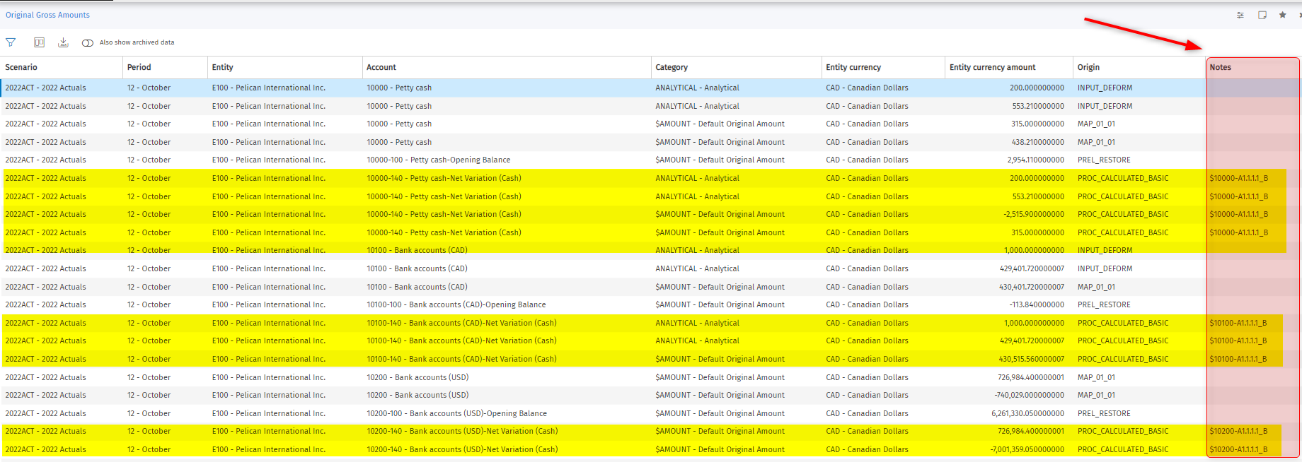
Screenshot 3 – Column Note from System Reports »» Original Gross Amounts
- From the user mode in the path System Reports » Other » Notes

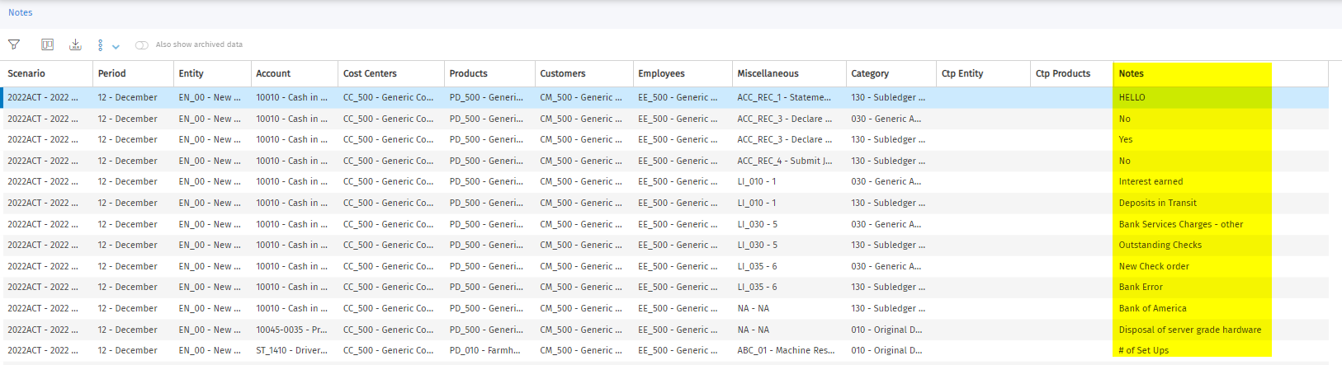
Screenshot 4 – Column Note from System Reports »» Other »» Notes

- From a SQL syntax query directly to the DSL table.

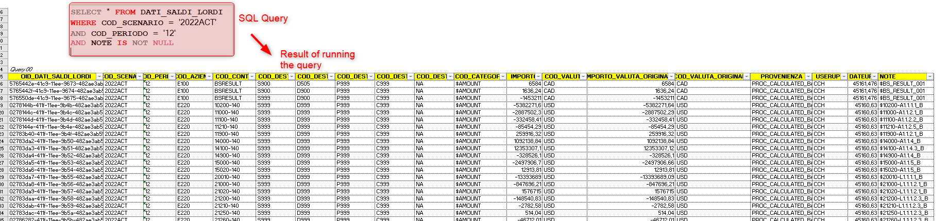

Screenshot 5 – Column Note from SQL Query
- From the Workflow » Other Edit Windows » Notes

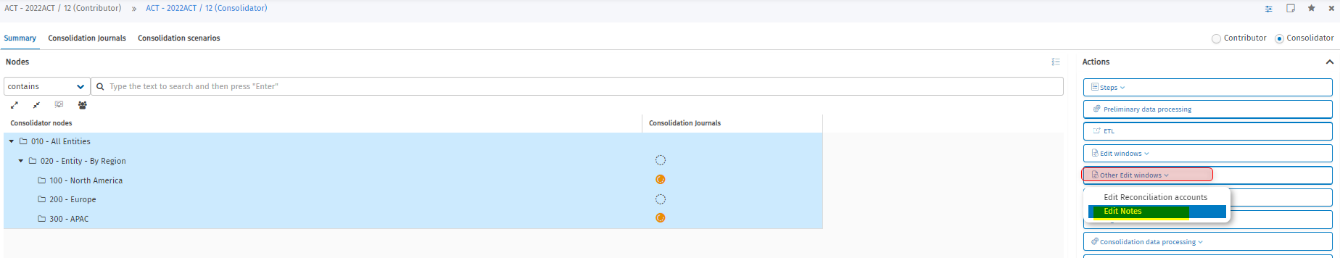
Screenshot 6 – Workflow process from Consolidator » Other Edit Window » Notes

- DATI_NOTE and DATI_COMMENTI
      - DATI_NOTE

The DATI_NOTE table is a table that functions to store notes that the user enters from reports. Notes cannot be set at node level, only at the lowest element level.

      - DATI_COMMENTI
The DATI_COMMENTI table is a table that functions to store comments during the data entry step in one or more cells, even files can be attached to provide information about the inserted data. For this, the following must be taken into account;

- The cell must be editable
- The form must be in data entry mode

      - Differences between DATI_NOTE and DATI_COMMENTI
Main differences between both tables DATI_NOTE and DATI_COMMENTI;
DATI_NOTE | DATI_COMMENTI
Could serve for storing textual information related to financial data. | Could serve for contain text-based comments and add and attachment to every comment.
Will be visible or not inside the form based on what is specified in the configuration for the "Display data entry comments in reports navigation” option. | Comments are visible in all forms for which the defined filters are the same as those of the cell to which the comment was linked.
Notes can be filled in from an open form in data entry mode or from the Process in the "Other Edith Windows"»» “Notes window”. | The form must only be opened in data entry mode.
Notes are enabled to be displayed in navigation mode.  They can be downloaded through the process in the path "Other Edit Window " Notes " Option download or from “System reports” path. | Comments are enabled to be displayed in navigation mode and attachments.  Can be downloaded via the comment details window.
It could be used to insert explanatory notes for executing a step, be it rejecting data from an entity, reconciling accounts, etc.
 | If the cell is no longer editable because it contains data that has already been submitted, to insert a comment the user must have function 0004073 active in their own role.

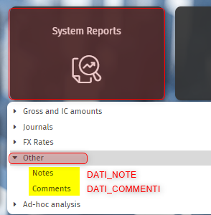

Screenshot 7 – Notes and Comments path
Note: From Tagetik Web in “User” Mode, you will notice that in the "System reports" path you will find the "Other" option that allows you to view "Notes and Comments". These are directly associated to the DATI_NOTE and DATI_COMMENTI tables.

4. How to add data to the DATI_NOTE
From a data entry form, we can see the editable cells for the "Notes" field and be able to include the required note. This can be done from the input form in Web mode or from Excel.
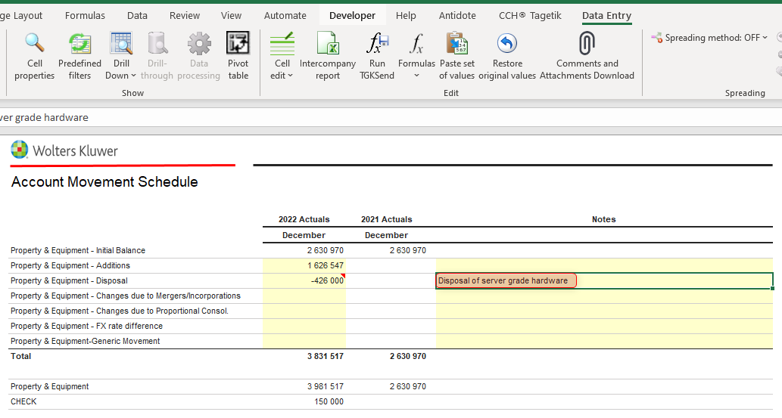
Screenshot 8 – Notes from Data Entry Form

- How to add data to the DATI_COMMENTI
From a data entry form, we can see the editable cells for the "Comments" field and be able to include the required comment. This can be done from the input form in Web mode or from Excel.

- The first step, from the data entry form, is to select the Edit cells " Comments / attachemnts tab.

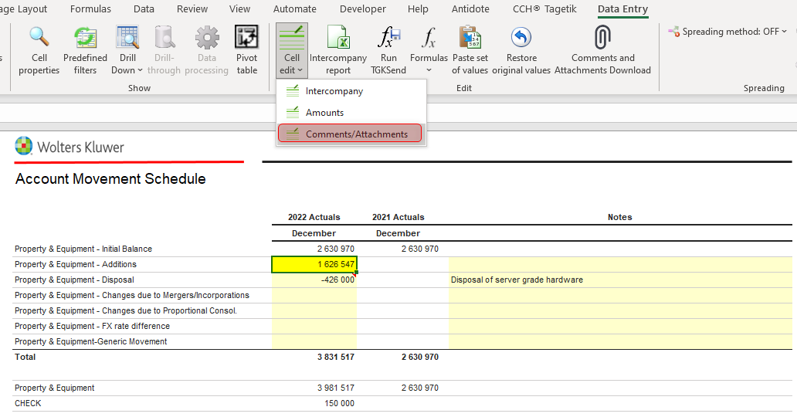
Screenshot 9 – Cell edit »» Comments / Attachments

- The second step is, in the window that opens, select the icon (+) to add a comment. At the bottom of the window you will see a blank space where you can write the comment you want to add.

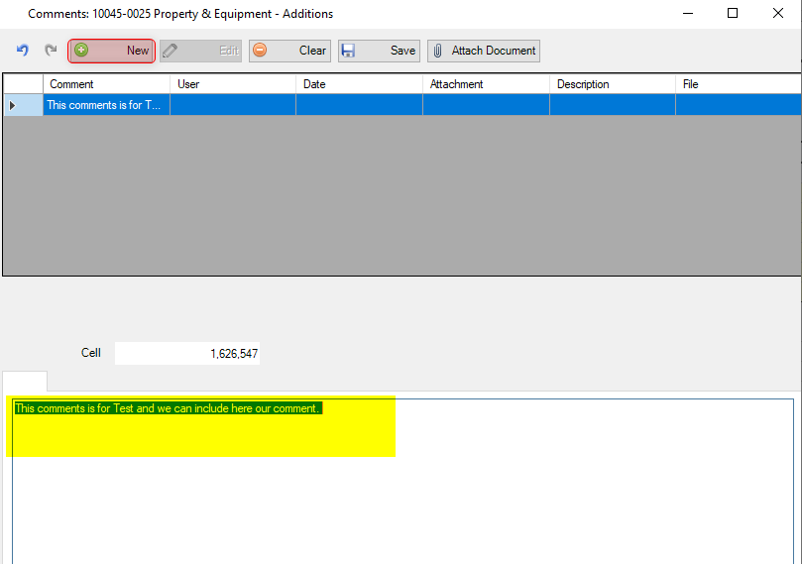
Screenshot 10 – Create a new comment and save
- The last step is, if you want to include an attachment, you will find the icon next to "save" to search for a file related to the comment.

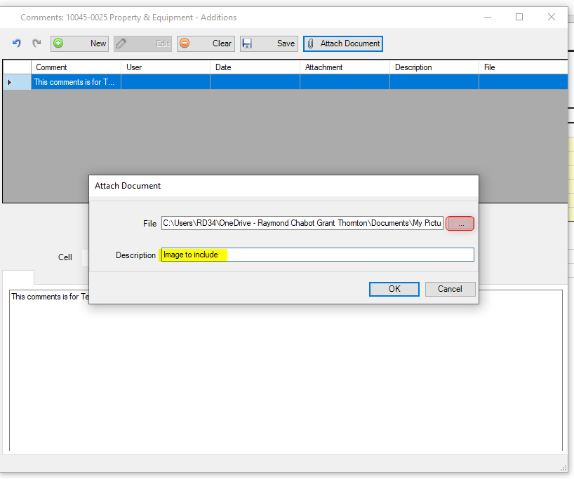
Screenshot 11 – Include an attachement
Note: The last step is, if you want to include an attachment, you will find the icon next to "save" to search for a file related to the comment.

- The data entry report is now displayed with the previously created comment and attachment. It is displayed as follows;

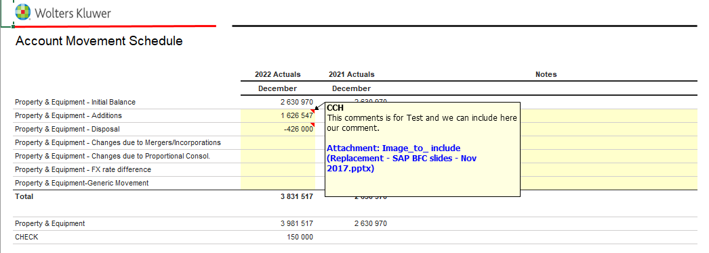
Screenshot 12 – Data Entry Form with comments
 | For attachments, it is important to note that only certain formats are supported, such as;  - Xlsx  - docx  - Ppt  - Pdf  Not allowed files;  - Png  - jpg

A step-by-step document is attached below.

Failed: Corrected, failed, and approved:

We, the RCGT team, confirm that the expected result was obtained in the execution of this test, and we consider this test approved.

NAME | ROL | SIGNATURE

